Subject: Mathematics
Grade: 6
Strand: Geometry
Duration: 3 x 60 minutes
Sub-theme: Properties of Polyhedral
Focus Question: How are the characteristics of geometric solids similar and different?
Standard:
Explore paths, geometric shapes and space and make generalization about geometric relationships within the environment.

Benchmark:
Model and explore polyhedron (tetrahedron and octahedron) by noting their properties and nets.

ICT Attainment Target (s):
COMMUNICATION AND COLLABORATION - use technology to communicate ideas and information, and work collaboratively to support individual needs and contribute to the learning of others.
DESIGNING AND PRODUCING - use digital tools to design and produce creative multimedia products to demonstrate their learning and understanding of basic technology operations.

Prerequisite knowledge/skills: Students should know how to:
- Identify and name plane shapes.

Specific Objectives: Students should be able to:
- Draw and describe nets of prisms: triangular base.
- Identify and create solids that are polyhedral (tetrahedron, hexahedron, and octahedron).
- Classify solid shapes (prisms, pyramids and polyhedron) according to their properties.

Teaching/Learning Resources:
Solids, Multimedia projector, Nets of solids, Internet-generated devices (smartphones, tablets, laptops etc.) , Charts/Tables

Key Skills:
Drawing, distinguish between properties, Construct nets of solids, Describe properties of solids,
Engage in group activities.

Key Vocabulary:
Polyhedra, Tetrahedron, Cubes/cuboids, Octahedron, Hexahedron, Faces, Edges, Vertices, Pyramid, Prism, Nets, Solids, Properties/Characteristics

Learning Outcome: Students will be able to:
- Accurately draw and describe nets of select solids;
- Identify and create solids that are polyhedral;
- Correctly classify solid shapes (prisms, pyramids and polyhedron) according to their properties.
Day One
Topic: Exploring Triangular Prism Nets

Duration: 60 minutes
Specific Objectives: By the end of this lesson, students will be able to:
- draw and describe nets of prisms with a triangular base.
Resources/Materials:
Whiteboard or chalkboard, Markers or chalk, Visual aids (e.g., physical triangular prism models, pictures of prism nets), Index cards or small pieces of paper, Chart or poster with key geometric terms and their meanings, Rulers, scissors, and glue (for hands-on activity), Worksheets or handouts

Content Outline: What are Triangular Prism Nets?
Imagine you have a magical triangular prism—a solid 3D shape with a triangular base and three rectangular faces. A net of a triangular prism is like a flattened, unfolded version of the prism. It shows all the faces of the prism laid out flat, forming a 2D shape. Nets help us visualize how the 3D prism looks when it's opened up and laid flat.

Drawing Triangular Prism Nets:
Drawing a triangular prism net is like solving a puzzle! To create a net, we need to accurately represent the triangular base and three rectangular faces on a flat surface.
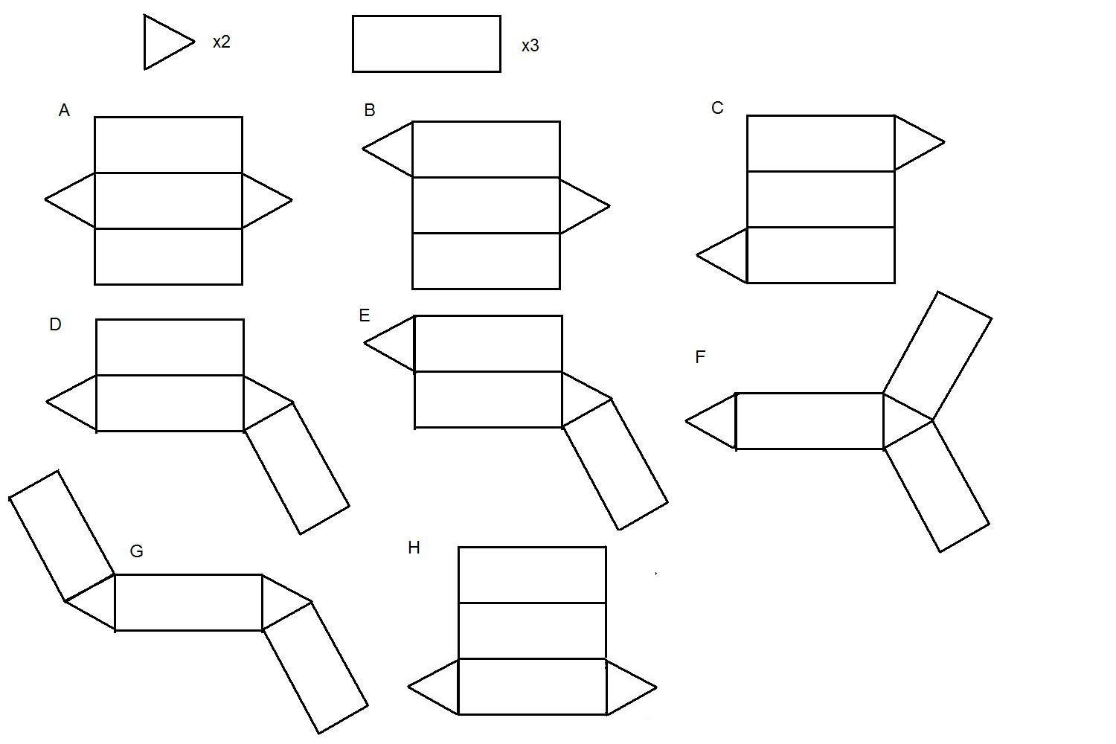

Let's break down the steps:
- Start with the Triangular Base: Draw a triangle on your paper with sides of the specified measurements. Make sure to label each side correctly.
- Add the Rectangular Sides: Extend the sides of the triangular base to form three rectangles connected to the triangle. Each rectangle represents one of the three rectangular faces of the prism.
- Assemble the Net: Cut out your drawing along the edges and carefully fold along the lines to form the 3D triangular prism. Voilà! You've unfolded the triangular prism into its net.

Describing the Triangular Prism Net:
Now that you've drawn the net, let's describe the magical properties of the triangular prism!
- Triangular Base: The net shows a triangle at the bottom—this is the base of the triangular prism. The triangle's sides represent the prism's base edges.
- Rectangular Sides: On each side of the triangular base, you'll find rectangles. These rectangles form the prism's three rectangular faces.
- Folding Magic: When you fold the net along the lines, it magically transforms into the original 3D triangular prism. This shows how the triangular base and rectangular faces fit together perfectly to create the solid shape.

Teaching /Learning Procedure:
Engage:
Teacher will begin the lesson by asking the students the following questions:
- "What do you know about prisms?
- How are they different from other 3D shapes?"
She will allow students to share their ideas and prior knowledge about prisms and their properties.

Explain:
Teacher will introduce the concept of a triangular prism and explain that it is a type of prism with a triangular base and rectangular sides. She will point out that prisms have faces, vertices and edges and that the shape of its base gives it its name.

Students will be shown visual aids, such as physical triangular prism models or pictures of prism nets, to help them visualize the shape.

Explore:
In small groups, Students will be provided with index cards or small pieces of paper containing measurements of a triangular prism's sides and height.
For example:
- Base: Triangle with sides of 5 cm, 6 cm, and 7 cm
- Height: 8 cm

Each group will be instructed to draw the net of the triangular prism on a piece of paper, labelling each face (triangle and rectangles) accordingly.

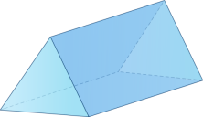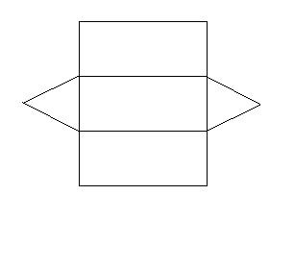
Students will be encouraged to use rulers to measure and draw the sides accurately and to visualize how the net folds to form the 3D prism.

After completing the drawing, each group will be asked to describe their net, highlighting the triangular base and rectangular sides.

Elaborate:
Teacher will provide each group with a printed net template of a triangular prism.
Students will be instructed to cut out the net along the edges and fold it to form the 3D shape.

As they construct the prism, students will be encouraged to identify the triangular base and rectangular sides.

Evaluate:
Each group will present their net drawings and explain the characteristics of a triangular prism based on their constructed 3D shape.

Students along with teacher will review the drawings as a class, checking for accuracy and addressing any questions or misconceptions.

In conclusion:
Teacher will:
- Summarize the main points of the lesson, emphasizing the unique features of triangular prisms and how to draw and describe their nets.
- Reinforce the idea that nets help us visualize and understand 3D shapes like prisms more effectively.
- Encourage students to explore other prisms and their nets to expand their understanding of geometric shapes.

Homework:
Provide students with additional triangular prism measurements and ask them to draw and describe the corresponding nets as homework.

For advanced students, introduce other types of prisms (e.g., pentagonal prism, hexagonal prism) and challenge them to draw and describe their nets.

Teacher Evaluation:
Strengths:
_____________________________________________________________________________ _____________________________________________________________________________
_____________________________________________________________________________ _____________________________________________________________________________
_____________________________________________________________________________

Weaknesses:
_____________________________________________________________________________ _____________________________________________________________________________ _____________________________________________________________________________ _____________________________________________________________________________
_____________________________________________________________________________ Action to be taken:
_____________________________________________________________________________ _____________________________________________________________________________ _____________________________________________________________________________
_____________________________________________________________________________
_____________________________________________________________________________

Day Two
Topic: Exploring Polyhedral Solids: Tetrahedron, Hexahedron, and Octahedron

Duration: 60 minutes
Specific Objectives: By the end of this lesson, students will be able to:
- to identify and create three polyhedral solids: tetrahedron, hexahedron (cube), and octahedron.

Resources/Materials:
Whiteboard or chalkboard, Markers or chalk, Visual aids (e.g., 3D models of tetrahedron, hexahedron, and octahedron), Index cards or small pieces of paper, Chart or poster with key geometric terms and their meanings, Scissors, glue, and construction paper (for hands-on activity)
Worksheets or handouts.

Content Outline: What are Polyhedral Solids?
Polyhedral solids are three-dimensional shapes made up of flat faces, straight edges, and vertices (corners). These intriguing solids have captured the imagination of mathematicians and scientists for centuries.

Meet the Triumphant Trio of Polyhedral Solids:
- The Mighty Tetrahedron: The tetrahedron is a warrior of geometry! It stands tall with four triangular faces, four edges, and four vertices. Imagine a pyramid with a triangular base and three more triangular faces meeting at the top—voilà, you have a tetrahedron!
- The Resilient Hexahedron (Cube): The hexahedron, often known as a cube, is one of the most common polyhedral solids. It boasts six square faces, twelve edges, and eight sturdy vertices. You'll find cubes in dice, building blocks, and even your very own Rubik's Cube!
- The Dazzling Octahedron: The octahedron is a gem among polyhedral solids! It dazzles with eight triangular faces, twelve edges, and six magnificent vertices. Picture two pyramids with their bases joined together—behold, the octahedron!

Creating Polyhedral Solids:
Creating polyhedral solids is like sculpting with magic! Let's see how to bring these enchanting shapes to life:
- The Tetrahedron: Start with a triangle on paper. Connect each vertex of the triangle with lines to form a pyramid. Fold along the lines and glue the edges to complete your marvellous tetrahedron.
- The Hexahedron (Cube): Draw six squares on paper. Connect the squares with lines to form a 3D box shape. Cut along the lines, fold, and glue the edges together to craft your very own cube!
- The Octahedron: Begin with two triangles, each pointing in opposite directions. Connect their corresponding vertices to create a mesmerizing octahedron. Fold and glue the edges to make it stand tall!

Teaching/Learning Procedure:
Engage and Explain:
Teacher will begin the lesson by asking the students:
- "Have you heard of polyhedral solids?
- Can you name any of them?"
She will allow students to share their ideas and prior knowledge about 3D shapes and polyhedrons.

Students will be Introduced to the concept of polyhedral solids. Teacher will then explain that they are three-dimensional shapes with flat faces, edges, and vertices.

Students will be encouraged to examine display of visual aids or models of the tetrahedron, hexahedron (cube), and octahedron to help students visualize these polyhedral solids.

Explore:
Students will be divided into small groups. Each group will be provided with index cards or small pieces of paper containing information about one of the polyhedral solids (tetrahedron, hexahedron, or octahedron).

For example:
- Group 1: Tetrahedron Description: A polyhedron with four triangular faces, four edges, and
four vertices.
- Group 2: Hexahedron (Cube) Description: A polyhedron with six square faces, twelve edges,
and eight vertices.
- Group 3: Octahedron Description: A polyhedron with eight triangular faces, twelve edges,
and six vertices.

Each group will create a visual representation of their assigned polyhedral solid using construction paper, scissors, and glue.

Students will be instructed to label the faces, edges, and vertices of their polyhedral while discussing the characteristics of each shape.

Elaborate:
Each group will be asked to present their polyhedral solids to the class, explaining their construction and describing the key features of each shape.

Allow other students to ask questions or add any additional information about the polyhedra.

Evaluate:
Students will be provided with worksheet or handout with images of various polyhedral solids. They will be asked to identify and label the tetrahedron, hexahedron (cube), and octahedron among the images.

Review the answers together as a class, checking for accuracy and addressing any questions or misconceptions.

In conclusion:
Teacher will:
- Summarize the main points of the lesson, emphasizing the unique characteristics of tetrahedron, hexahedron, and octahedron as polyhedral solids.
- Reinforce the idea that polyhedral solids are three-dimensional shapes with specific face, edge, and vertex configurations.
- Encourage students to continue exploring polyhedral solids and their properties, fostering a deeper understanding of 3D geometry.

Homework:
Provide students with additional polyhedral solids to identify and describe as homework.

For advanced students, introduce other polyhedral solids such as dodecahedron and icosahedron, challenging them to identify and create these shapes.

Teacher Evaluation:
Strengths:
_____________________________________________________________________________ _____________________________________________________________________________
_____________________________________________________________________________ _____________________________________________________________________________
_____________________________________________________________________________
Weaknesses:
_____________________________________________________________________________ _____________________________________________________________________________ _____________________________________________________________________________ _____________________________________________________________________________
_____________________________________________________________________________

Action to be taken:
_____________________________________________________________________________ _____________________________________________________________________________ _____________________________________________________________________________
_____________________________________________________________________________
_____________________________________________________________________________

Day Three
Topic: Exploring Solid Shapes: Prisms, Pyramids, and Polyhedral Classification

Duration: 60 minutes
Specific Objectives: By the end of this lesson, students will be able to:
- classify solid shapes (prisms, pyramids, and polyhedral) according to their properties.

Resources/Materials:
Whiteboard or chalkboard, Markers or chalk, Visual aids (e.g., pictures or models of prisms, pyramids, and polyhedral), Index cards or small pieces of paper, Chart or poster with key geometric terms and their meanings, Worksheets or handouts.

Content Outline: Solid Shapes and Their Properties:
Solid shapes are three-dimensional figures that have length, width, and height. They exist all around us, from the buildings we live into the objects we use every day.

Let's focus on three special types of solid shapes: prisms, pyramids, and polyhedra.
- Prisms: Imagine two identical and parallel faces called bases, connected by rectangular sides. That's a prism! The bases can be any polygon (e.g., triangle, square, pentagon) with straight sides. Prisms have a constant cross-section along their height, giving them a uniform appearance.
- Pyramids: Pyramids are captivating structures with a polygonal base and triangular faces that meet at a single point called the apex. The base can be any polygon, and the number of triangular faces depends on the number of sides the base has. The height of a pyramid is the perpendicular distance from the apex to the base.
- Polyhedra: Polyhedra are 3D shapes with flat faces, straight edges, and vertices (corners). They come in various forms and sizes, but they all share these defining characteristics. Prisms and pyramids are also considered types of polyhedra.

Classifying Solid Shapes:
Now that we know about prisms, pyramids, and polyhedra let's put our classification skills to the test:
- Identify the Shape: Take a look around your room or school. Can you spot any solid shapes? Look for objects with distinct faces, edges, and vertices. Try to identify if they are prisms, pyramids, or other types of polyhedra.
- Recognize the Properties: For prisms, focus on the two identical and parallel bases connected by rectangular sides. For pyramids, look for a polygonal base with triangular faces meeting at an apex. For other polyhedra, notice the flat faces, straight edges, and vertices.
- Real-World Examples: Prisms are prevalent in buildings, such as triangular roof prisms on houses or rectangular wall prisms in classrooms. Pyramids can be found in ancient structures like the Great Pyramid of Giza. Polyhedra can be seen in dice, boxes, and other everyday objects.

Teaching/Learning Procedure:
Engage:
Students will participate in a discussion, using the following questions:
- "What do you know about solid shapes?
- Can you name any examples of prisms, pyramids, and polyhedra?"

Teacher will allow students to share their ideas and prior knowledge about 3D shapes and their properties. She will Introduce the concept of solid shapes and explain that they are three-dimensional figures with length, width, and height.

Students will examine display visual aids, such as pictures or models, of prisms, pyramids, and polyhedra to help students visualize these solid shapes.

Explain and Explore:
Students will be divided into groups of 3-4. Each group will be provided with index cards or small pieces of paper containing information about one of the solid shapes (prism, pyramid, or polyhedron).
For example:
- Group 1: Prism Description: A solid shape with two identical and parallel faces (bases)
connected by rectangular sides.
- Group 2: Pyramid Description: A solid shape with a polygonal base and triangular faces that
meet at a common vertex (apex).
- Group 3: Polyhedron Description: A solid shape with flat faces, straight edges, and vertices
(corners).
Each group will be instructed to discuss and find examples of their assigned solid shape in their surroundings or from pictures provided.

Students will be encouraged to create posters or drawings illustrating the key features and examples of their assigned solid shape.

Elaborate:
Each group will be asked to present their posters or drawings to the class, explaining the properties of their assigned solid shape and providing real-world examples.

Teacher with students will review the presentations as a class, checking for accuracy and addressing any questions or misconceptions.

Evaluate:
Teacher will summarize the main points of the lesson, emphasizing the unique properties of prisms, pyramids, and polyhedra.

She will reinforce the idea that classification helps us understand and organize different solid shapes based on their characteristics.

Students will be encouraged to continue exploring solid shapes in their daily lives and to identify more examples of prisms, pyramids, and polyhedra in the world around them.

Homework:
Provide students with additional pictures or objects of 3D shapes and ask them to classify them as prisms, pyramids, or polyhedra based on their properties.

For advanced students, introduce other types of solid shapes, such as cylinders, cones, and spheres, and explore their properties and classification.

Teacher Evaluation:
Strengths:
_____________________________________________________________________________ _____________________________________________________________________________
_____________________________________________________________________________ _____________________________________________________________________________
_____________________________________________________________________________
Weaknesses:
_____________________________________________________________________________ _____________________________________________________________________________ _____________________________________________________________________________ _____________________________________________________________________________
_____________________________________________________________________________

Action to be taken:
_____________________________________________________________________________ _____________________________________________________________________________ _____________________________________________________________________________
_____________________________________________________________________________
_____________________________________________________________________________

Remember to adjust the lesson plan and activities based on your students' learning pace and needs. Make the learning experience interactive and enjoyable to enhance understanding and engagement.

