Lesson Plans for week beginning Monday, November 18, 2019 to Friday, November 22, 2019
Subject: Social Studies
Grade: 6
Duration: 60 minutes x 3
Unit Title/Theme: The physical environment and its impact on human activities
Focus Question: How are mountains important to people’s lives and how do human activities affect mountain environments?

Attainment Target 1:

Understand the processes and forces that have influenced the physical and built environment

Objectives:
- Develop working definitions for and use correctly the following concepts/terms: mountain, mountain range, hill, valley, plateaux, landforms, plains, forest reserve, summit, slopes
- Create a thematic map showing the name and location of the major mountains in Jamaica
- Use different criteria to rank mountains and mountain ranges
- Use data to make comparisons and draw conclusions about how mountains affect weather and climate

Key Skills: Developing concepts, gathering information from maps, ranking data, Mapping information
Key Vocabulary: Habitat, mountain, hill, valley, plateaux, landforms, plains, leeward, windward, rain shadow area, forest reserve, protected area, indigenous species,

Materials/Resources: Maps, Wall maps, Globes, Atlases, Diagrams, Computer, Multimedia Projector,
Internet, Jamaica Primary Social Studies student Book 6
http://www.my-island-jamaica.com/mountains_in_jamaica.html

Content Summary: A landform is a natural or artificial feature of the solid surface of the earth. Landforms are physical or relief features such as mountains, valleys, hills, plains, plateau and beaches.

Day one:
Topic: Mountain environment – Landforms
Prior Knowledge: Students should be able to:
- Explain the term relief.
- Explain how relief/orographic rainfalls occurs.
Procedures/Activities:
Engage:
Students will watch video about the different types of landforms. They will then be guided into a discussion with the following questions:
- What was the video about?
- What are landforms?
- Are all landforms alike?
- What are the different types of landforms that were highlighted in the video?
- Which features/landforms are highland features and which are lowland features?
- Can you identify any of these landforms in your community?
Explore:
Students will work with a partner to develop a graphic organiser such as a concept or mind map to show their understanding of the terms:
mountain, hill, valley, plateaux, landforms, plains, summit, slopes.

Graphic organiser must include for each feature:
- Its attributes/characteristics.
- At least one example.
- A picture and part of speech.
- A sentence in which the concept is used appropriately

Explain:
A landform is a natural or artificial feature of the solid surface of the earth. It is the physical or relief features such as mountains, valleys, hills, plains, plateau and beaches.
Landforms can be either highland or lowland.
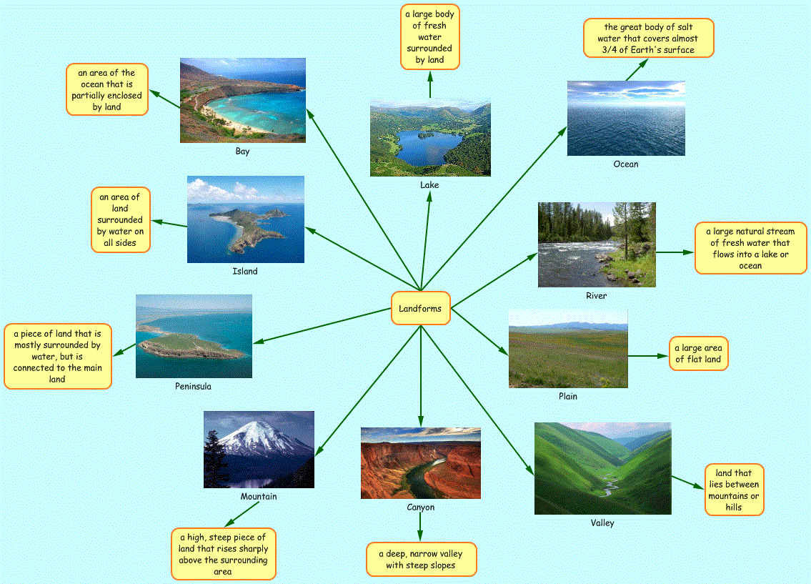
Elaborate:
Students will study the map on page 69 of Jamaica primary Social Studies Student Book 6, they will then, answer the following questions.
- Which colour is used for the highest areas of land?
- How high are they?
- What symbol is used to show a mountain peak?
- What measurement is used to record the height of a mountain peak?
Evaluate:
Students will answer the question below in their notebooks, then copy information from the Fact Box and Did you know? Section on page 70 of said text.
Use the diagram on page 69 to describe the difference between a mountain, a hill and a plateau.
Assessment Criteria: Were students able to:
- Complete graphic organizers showing clear understanding of the concepts with correct attributes and examples

Lesson Evaluation:
____________________________________________________________________________________________________________________________________________________________________________________________________________________________________________________________________________________________________________________________________________________________________________________________________________________________________________________________________________________________________________________________________________________________________________________________________________________________________________________________________________________________________________________________________________________________________________________________________________________________________________________________________________________________________________________________________________________________________________________________________________________________________________________________
Objectives were met by:
_____________________________________________________________________________________________________________________________________________________________________________________________________________________________________________________________________________________________________________________________________________________________________________________________________________________________________________________________________________________________________________________________________________________________________________________________________________________________________________________________________________________________________________________________________________________________________________________________
Actions to be taken:
________________________________________________________________________________________________________________________________________________________________________________________________________________________________________________________________________________________________________________________________________________________________________________________________________________________________________________________________________________________________________________________________________________________________________________________________________________________________________________________________________________________________________
Day Two:
Topic: Mountain environment – Mountains in Jamaica
Prior Knowledge: Students should be able to:
- Explain the term relief.
- Explain how relief/orographic rainfalls occurs.
Procedures/Activities:
Engage:
Students will watch a video about mountains. They will then, visit website at http://www.my-island-jamaica.com/mountains_in_jamaica.html for information about mountains in Jamaica.

Students in their respective groups, will discuss and compare information received from both sources and share their what they have learnt with the rest of their classmates.

Explore:

Students will refer to the map on page 69 or look at a physical map of Jamaica in their atlas. They will either draw a sketch map of Jamaica or use a blank map of Jamaica. Students will then:
- Draw and shade land over 600 metres.
- Mark on the major mountains (not hills).
- Create a key for their map using the correct colours and symbols.
- Insert the name of the mountain ranges in the correct locations.
- Give their map a title.

Explain:
Teacher will bring students attention to pages 70 and 71 of social studies textbook, they will read, examine the pictures and discuss information from the passage entitled ‘Mountains in Jamaica’.
Students will in their own words share what they learn or understand from the passage they read.
Elaborate;
Students will examine and discuss information about the mountains and hills of Jamaica shown in table on page 72 of said textbook.
They will then, copy the table shown the mountains and hills of Jamaica in their notebooks.
Evaluate:
Using the relief map on page 71, students will find the following mountains and hills and say in which parish is each of them located.
Assessment Criteria: Were students able to:
- Place the features correctly on a sketch or blank map of Jamaica, insert correct names and locations.

Lesson Evaluation:
____________________________________________________________________________________________________________________________________________________________________________________________________________________________________________________________________________________________________________________________________________________________________________________________________________________________________________________________________________________________________________________________________________________________________________________________________________________________________________________________________________________________________________________________________________________________________________________________________________________________________________________________________________________________________________________________________________________________________________________________________________________________________________________________
Objectives were met by:
_____________________________________________________________________________________________________________________________________________________________________________________________________________________________________________________________________________________________________________________________________________________________________________________________________________________________________________________________________________________________________________________________________________________________________________________________________________________________________________________________________________________________________________________________________________________________________________________________
Actions to be taken:
________________________________________________________________________________________________________________________________________________________________________________________________________________________________________________________________________________________________________________________________________________________________________________________________________________________________________________________________________________________________________________________________________________________________________________________________________________________________________________________________________________________________________
Day Three:
Topic: Mountain environment – Mountains in Jamaica
Prior Knowledge: Students should be able to:
- Explain the term relief.
- Explain how relief/orographic rainfalls occurs.
Procedures/Activities:
Engage:
Students with teacher will view and examine Google Maps showing Jamaica’s relief. They will be guided into a discussion about the different features seen and/or identified on the map.
Student will then, make a list of all the mountain ranges, mountain peaks and hills they saw on the map.

Explore:
Using a detailed atlas map, students will identify the heights above sea level of the features listed above. Some peaks will have their heights on the map, whereas other ranges and hills may not.
Students will need to use the map key to estimate some heights.

Explain:
Students will create a table to show the heights above sea level, ranked in order, either ascending or descending. They will share the table they have created with the class, explaining the order of ranking.

Elaborate:
Students will work in groups, to brainstorm other criteria they could use to rank mountains and mountain ranges. They will use one of their criteria to rank Jamaica’s mountains.

Evaluate:
Students will find a mountain or hill near their school and estimate its height using the map or use Google earth to find out its height.

Assessment Criteria: Were students able to:
- Complete table with mountains ranges ranked in ascending or descending order.

Lesson Evaluation:
____________________________________________________________________________________________________________________________________________________________________________________________________________________________________________________________________________________________________________________________________________________________________________________________________________________________________________________________________________________________________________________________________________________________________________________________________________________________________________________________________________________________________________________________________________________________________________________________________________________________________________________________________________________________________________________________________________________________________________________________________________________________________________________________
Objectives were met by:
_____________________________________________________________________________________________________________________________________________________________________________________________________________________________________________________________________________________________________________________________________________________________________________________________________________________________________________________________________________________________________________________________________________________________________________________________________________________________________________________________________________________________________________________________________________________________________________________________
Actions to be taken:
________________________________________________________________________________________________________________________________________________________________________________________________________________________________________________________________________________________________________________________________________________________________________________________________________________________________________________________________________________________________________________________________________________________________________________________________________________________________________________________________________________________________________

Day Four: Thursday, January 16, 2020
Topic: Mountain environment – Mountains in Jamaica
Prior Knowledge: Students should be able to:
- Explain the term relief.
- Explain how relief/orographic rainfalls occurs.
Procedures/Activities:
Engage:
Students will watch video about the major mountains in Jamaica. In groups of 5s, they will name and discuss the major mountains that can be found in Jamaica. Students will make a list of these mountains.

Explore:
Using their atlas, student will find and make a note of the location for each of these major mountains in Jamaica, by town and parish.

Explain:
Students will then, use the above information to correctly complete a blank map of Jamaica showing the major mountains.

Elaborate:
Student will create a key for their map using the correct colours and symbols. They will then insert the names of mountain ranges on the map in the correct location.

Evaluate:
Students will complete activities A, B, C and D on page 34 – 36 of Jamaica social studies workbook 6.

Assessment Criteria: Were students able to:
- Complete a map of Jamaica showing major mountain ranges in their correct location, with names inserted and correct colours and symbols used.

Lesson Evaluation:
____________________________________________________________________________________________________________________________________________________________________________________________________________________________________________________________________________________________________________________________________________________________________________________________________________________________________________________________________________________________________________________________________________________________________________________________________________________________________________________________________________________________________________________________________________________________________________________________________________________________________________________________________________________________________________________________________________________________________________________________________________________________________________________________
Objectives were met by:
_____________________________________________________________________________________________________________________________________________________________________________________________________________________________________________________________________________________________________________________________________________________________________________________________________________________________________________________________________________________________________________________________________________________________________________________________________________________________________________________________________________________________________________________________________________________________________________________________
Actions to be taken:
________________________________________________________________________________________________________________________________________________________________________________________________________________________________________________________________________________________________________________________________________________________________________________________________________________________________________________________________________________________________________________________________________________________________________________________________________________________________________________________________________________________________________

