Lesson Plans: Honouring our Country – Our National Symbols – The Jamaican Flag
Subject: Social Studies
Grade: 6
Duration: 60 minutes x 3
Unit Title/Theme: Our Common Heritage
Focus Question: How do we show respect and loyalty for our country?
Attainment Target 3:

- Know and value the contributions of communities and institutions in fostering national, regional and international integration

ICT Attainment Targets:

- COMMUNICATION AND COLLABORATION- use technology to communicate ideas and information and understanding for a variety of purposes.
- DESIGNING AND PRODUCING – use technology to design and produce multimedia products to demonstrate their creative thinking.

- RESEARCH, CRITICAL THINKING, PROBLEM SOLVING AND DECISION MAKING – use technology to develop a logical process for decision making and problem solving.

- DIGITAL CITIZENSHIP –recognize the ethical, social and legal issues and implications surrounding the use of technology.

Objectives:

- Develop working definitions and use correctly the following concepts: emblem, flag, coat-of-arms, symbols, nationhood, anthem, crest, bearing, motto, patriotism
- Explain what national symbols and emblems are and analyze their importance to nationhood.
- Identify and describe the national symbols of Jamaica.
- Examine images which show the changes in the Jamaican Coat-Of-Arms, justify the changes made
- Tell the meaning of each colour on the Jamaican flag.
- Recite and interpret the National Anthem and National Pledge
- Select a group/organization, describe its purpose and values then design symbols to reflect its purpose and values
- Observe etiquette to be adhered to regarding national symbols and emblems
- Assess the role and responsibilities of the citizens in acknowledging and maintaining pride in our national symbols.
- Show respect for our national symbols and emblems.
- Show respect for individuals who hold public
- Negotiate and compromise to resolve conflict during collaborative work
Key Skills: developing meaning, designing, organising information, interpreting, strategic thinking, presenting logical argument, using information gathered to develop product, simulating to show understanding.
Key vocabulary nationhood, government, flag, loyalty, coat-of-arms, symbols, nationhood, nation-building, patriotism, national pride, national pledge, independence, anthem, reverence, celebration, crest, bearing, motto

Materials/Resources: http://opm.gov.jm/national-symbols-emblems/, http://www.jamaica-land-we-love.com/national-symbols-of-jamaica.html, https://www.nlj.gov.jm/?q=jamaican-national-symbls, Computer, Internet, Multimedia projector
Learning Outcomes
Students will be able to:

- Give correct meaning for the terms and concepts
- Use the concepts relating to national symbols in the appropriate context
- Identify and name the national symbols and emblems
- Exhibit patriotism for our nation
- Give a brief history of national symbols
- Use national symbols to create designs
- State the significance of national symbols
- Draw conclusions about the role and responsibilities of Jamaicans in maintaining respect and honour for national symbols
- Demonstrate respect for national symbols and holders of public office

Content summary: Jamaica became a nation on August 6, 1962. A nation is a people with a particular shared history who live in a particular place.
An independent nation is responsible for running its own affairs. Nationhood means being an independent and separate nation.
The Jamaican flag was first raised at the National Stadium at independence on August 6, 1962.
We sing the national anthem at official functions in Jamaica and abroad to identify us as a nation.
School children across Jamaica repeat the national pledge at functions and at devotions.
Day one:
Topic: Honouring our Country – Our National Symbols – The Jamaican Flag
Specific Objectives: At the end of lesson students should be able to: -
- Develop working definitions and use correctly the following concepts: emblem, flag, coat-of-arms, symbols, nationhood, anthem, crest, bearing, motto, patriotism
- Explain what national symbols and emblems are and analyze their importance to nationhood.
- Identify and describe the national symbols of Jamaica.
- Tell the meaning of each colour on the Jamaican flag.

Key Skills: developing meaning, designing, organising information.
Key vocabulary nationhood, government, flag, loyalty, coat-of-arms, symbols, nationhood, nation-building, patriotism, national pride, national pledge, independence, anthem, reverence, celebration, crest, bearing, motto

Materials/Resources: http://opm.gov.jm/national-symbols-emblems/
Content Outline: Our national symbols include the nation flag, the coat of arms, the motto, the national anthem, the national school song, the national pledge, the, national bird, flower, fruit and tree.
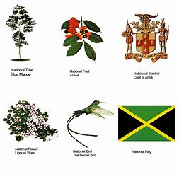
The colours of the flag are black green and gold.
The flag should be respected by all citizens, it should not touch the ground or used for decoration. The flag is flown on or near public buildings such as schools and police stations.
Prior Knowledge: Students should know:
- Know the national symbols of Jamaica.
Procedures/Activities:
Engage:
Students will watch video presentation on Jamaica’s National Symbols. Students will then be guided into a discussion about Jamaica’s national symbols and emblems, with the following questions and informational pieces:

- Did you know that long ago we used British money in Jamaica?

In 1969 pounds were replaced by the Jamaican dollar. A country’s own currency is itself a symbol of nationhood. The Jamaican currency shows national symbols, scenes and the faces of Jamaicans, such as our national heroes and heroine.

- What is nationhood?

Nationhood is being a separate, often independent nation, a large group of people united by common language, culture or economic ties.

Explore:

Students will read given information on pages 54 and 55 of the Jamaica Primary Social Studies textbook about what are national symbols, how we develop national symbols and our national symbols.
Students will then be guided into a discussion with the following question:

- Why do you think national symbols are important to nationhood?

Explain:

Students will be guided into a discussion about our national symbols using the story of the national flag on page 55 of the Jamaica Primary Social Studies text.

Teacher will ask: Did you know that before independence Jamaica flew the flag of Britain, the British flag?

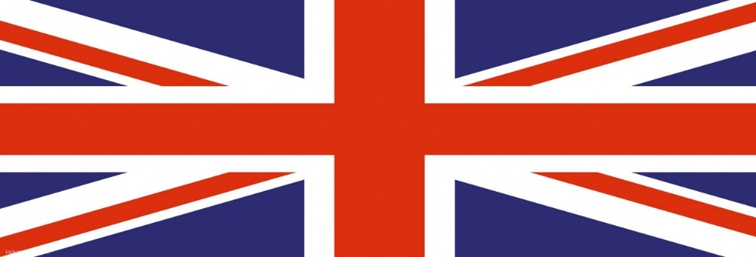

She will then tell the story: Before Jamaica became independent in the 1962, she flew the flag of Britain, the Union flag or Union Jack. When it was clear that Jamaica was to become independent a competition was held for the design of a new national flag. However, none of the entries received were thought good enough so the flag was designed by a committee from both political parties in the House of representatives.

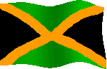

Elaborate:

Students will read over information about our national flag on page 55 of text. students will, in groups
discuss the colours of the flag and what they stand for/represents.

Students will then, using any creative form of their choice (song/poem/role play. etc.), to represent their
understanding/interpretation of what the colours of our national flag represent.

Evaluate:

Students will create and include images where possible a booklet of terms with their meaning relating to:- culture, flag, loyalty, coat-of-arms, symbols, nationhood, nation-building, patriotism, national pride, national pledge, independence, anthem, reverence, celebration, crest, bearing, motto. Images may be included.

Extended Learning:

Students will research online/offline other official flags of Jamaica. Paying special attention to when, where and why they are flown.
Visual Arts Activity:

Students will
- draw and colour the Jamaica flag, then display them in their class.
- Make small paper flags which their can wave at national events.
- Research to find pictures of other official flags used in Jamaica.

Assessment Criteria: Were students able to:
- Effectively expressed their understanding/interpretation of what the colours our national flag represent/means.
- Include correct definition of terms in booklet created.

Lesson Evaluation:
_________________________________________________________________________________________________________________________________________________________________________________________________________________________________________________________________________________________________________________________________________________________________________________________________________________________________________
Objectives were met by:
____________________________________________________________________________________________________________________________________________________________________________________________________________________________________________________________________________________________________________________________________________________
Day Two:
Topic: Honouring our Country – The National Anthem
Specific Objectives: At the end of lesson students should be able to: -
- Identify and describe the national symbols of Jamaica.
- Recite and interpret the National Anthem

Key Skills: interpreting
Key vocabulary national symbols, nationhood, nation-building, patriotism, national pride, national pledge, independence, anthem, reverence, celebration, crest.

Materials/Resources: http://www.jamaica-land-we-love.com/national-symbols-of-jamaica.html

Content Outline: The national anthem should be sung or played at public gatherings, flag-raising ceremonies and independence celebrations, when the Prime Minister of Governor-General attends an event and at schools’ flag-raising or lowering ceremonies.
When singing the national anthem, we should stand upright with hands by our sides and look ahead, boys and men should remove their hats and people wearing uniform should salute.

Prior Knowledge: Students should know:
- Know the national symbols of Jamaica.
Procedures/Activities:
Engage:
Students will listen to Jamaica’s national anthem, and national song at: Jamaica-land-we-love.com. In groups, they will:
- Discuss and interpret the lyrics of the national anthem
- Share their understanding of what each line means.

Explore:

Students will write out the national anthem and highlight the patriotic words and add new words to their booklet of terms.

Students in groups, will also research other patriotic songs and present one of them to the class.

Explain:

Students will be guided into a discussion about our national anthem using the “Did you know” activity on page 56 of the Jamaica Primary Social Studies text.

Teacher will ask: Do you know who created the national anthem?

She will then explain: The national anthem was created by the Reverend Honourable Hugh Sherlock and the Honourable Robert Lightbourne, and the music composed by the Honourable Robert Lightbourne, Mapletoft Poulle and Mrs. Poulle. It was first sung in 1962.

We stand at attention when singing our national anthem, with our hands at our sides without moving, as a form of respect to God, our country, others and ourselves.

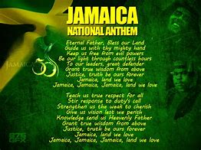

Students will then write the national anthem in their own words, as they understand it, then share it with their classmates.

Elaborate:

Students will learn the words of the national anthem and present it to the class in groups.

Evaluate:

Students will, work in their respective groups to create a class/school anthem and present it to the class.

Extended Learning:

Students will research online/offline to find out about the national symbols and emblems of other Caribbean countries. In groups, present information found to members of the class.
Visual Arts Activity:

Students will work in groups to:
- Make a collage using pictures of the national symbols and emblems of other Caribbean countries and display in the classroom.
Assessment Criteria: Were students able to:
- Discuss clearly and highlight the meaning of patriotic words and phrases in the national anthem and other patriotic songs.

- The song created should reflect the culture and character of the class/school, the wholesome values or aspirations shared by members of the class.
Lesson Evaluation:
_________________________________________________________________________________________________________________________________________________________________________________________________________________________________________________________________________________________________________________________________________________________________________________________________________________________________________
Objectives were met by:
____________________________________________________________________________________________________________________________________________________________________________________________________________________________________________________________________________________________________________________________________________________
Day Three:
Topic: Honouring our Country – The National Pledge
Specific Objectives: At the end of lesson students should be able to: -
- Identify and describe the national symbols of Jamaica.
- Recite and interpret the National Pledge

Key Skills: interpreting
Key vocabulary national symbols, nationhood, nation-building, patriotism, national pride, national pledge, independence, anthem, reverence, celebration.

Materials/Resources: http://www.jamaica-land-we-love.com/national-symbols-of-jamaica.html
https://www.nlj.gov.jm/?q=jamaican-national-symbls,

Content Outline: The national Pledge should be recited or played at public gatherings, flag-raising ceremonies and independence celebrations, when the Prime Minister of Governor-General attends an event and at schools’ flag-raising or lowering ceremonies.
When we repeat our national pledge, we are making a promise before God to do our best in making Jamaica and the world a better place.

Prior Knowledge: Students should know:
- Know the national symbols of Jamaica.
Procedures/Activities:
Engage:
Students will watch video https://www.youtube.com/watch?v=TFu1s7ZAdXI about Jamaica’s national pledge. In groups, they will:

- Discuss and interpret the lyrics of the national pledge
- Share their understanding of what each line means with the class.

Explore:
Students will listen to, then read the pledge aloud, they should make sure to recite pledge without any error or mistakes.
Explain:
Students will discuss and explain what the words of the pledge means. They will in pairs, take two lines each and prepare an explanation in their own words, then share their explanation with the class.

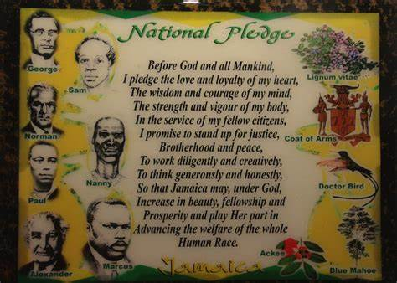
Elaborate:
Students will learn the words of the national pledge by heart and present it to the class in groups.

Evaluate:

Working in their respective groups, students will give their group a name and create a pledge for their group. They will then present it to the class.

Assessment Criteria: Were students able to:
- Discuss clearly and highlight the meaning of patriotic words and phrases in the national pledge.

- The pledge created should reflect the culture and character of the group, the wholesome values or aspirations shared by members of the group.

Lesson Evaluation:
_________________________________________________________________________________________________________________________________________________________________________________________________________________________________________________________________________________________________________________________________________________________________________________________________________________________________________

Objectives were met by:
____________________________________________________________________________________________________________________________________________________________________________________________________________________________________________________________________________________________________________________________________________________

