Subject: Mathematics
Grade: 6
Strand: Number
Duration: 60 minutes
Topic: Sets – Finite and Infinite
Focus Question: What are the special symbols and language I use when I work with sets?
Standard:
Know the value of numerals, associate them with their names, numbers, ordinals and use concrete objects to model patterns, expressions and numbers.

Benchmark:
Identify members of a set and associate same with the property of the given set.

Attainment Target:
- Make and interpret Venn diagrams.

Standards for Mathematical Practices
- Make sense of problems and persevere in solving them.
- Construct viable arguments and critique the reasoning of others.
- Attending to precision.

Prerequisite knowledge/skills: Students should know how to:
- Describe a set including the empty set.
- Differentiate between sets of counting, whole, odd, even, prime, composite and fractional numbers.
- Name any set using braces.
- Interpret the notation {a, b, c . . .} as a set whose elements go on and on

Specific Objectives: At the end of the lesson, students should be able to:
- Provide definitions for Finite and Infinite sets
- Identify members of finite and infinite sets.
- Differentiate between Finite and Infinite sets
- Classify sets as being Finite or Infinite

Teaching/Learning Resources:
Activity sheets #1, 2 and 3, Flip-chart, cartridge or blank paper, Strips of papers with related statements, Music

Key Vocabulary: Finite, Infinite, Set, Countable/Limited, Unlimited/Uncountable, Members/Elements
Content Outline:
An Infinite set has an endless/uncountable number of members such that the members are not able to be listed in their entirety. For example: {stars in the sky}
A finite set has a limited/countable number of elements where all the elements can be listed.
For example: {students in your class}
Teaching/Learning Procedure:
Engage:
As a whole Class group, stations will be set up in the classroom with the following captions –
- Even Numbers,
- Odd Numbers,
- Fractional Numbers,
- Modes of Transportation, and
- Vowels in the English Alphabet.
Students will be given a card (see Activity Sheet #1). Students will be asked where they think the item on their card belong.
Guided questions:
- What do you notice about the station captioned Fractional Numbers? Explain your thinking.
- Given a blank card, what would you write on it so that it would belong to the set of Fractional Numbers?
- Can any of the numbers on the cards that you have fit into another group of numbers not represented here? Give an example.
Explore:
In small Groups, students will be given two cards – one from Set A and one from Set B (See Activity Sheet #2).
Students will be asked to answer the following questions:
- How many items are in each set?
- Do you observe any difference between the sets you were given? Write a sentence to explain your answer.
- Give one word that would describe the number of elements in Set A and also one word for Set B.
Students will be given flip-chart, cartridge or blank paper to record their answers.
Explain:
In their small Groups, students will present their findings by posting up their work and explaining their thinking. The teacher will draw a table on the board with the headings Set A and Set B. The group leader will write the word they used to describe each set in the appropriate column.
As a whole Class group, teacher will choose questions that are appropriate for the words the students write.
Guided questions:
If finite and/or infinite is given by the students:
- Is there one word in the list that would represent all the other words?
If finite and/or infinite is not given by students:
- Is there one word that you can think of that would represent all the other words in each of the columns?
Note to teacher: Use context clues, if necessary, to elicit the words Finite and Infinite.
- Look at the sentence you wrote to explain the difference between your two sets, can you use it to define the terms Finite and Infinite? Write your definition.
- If not, how would you define the terms Finite and Infinite?
Students will share their definition with the rest of the class. The teacher will assist the students in coming up with a concrete definition of the terms Finite and Infinite using as much of the students’ input as possible.

Elaborate/Extend:
As a whole class group, students will play a game of Pass the Parcel where a bag of statements related to the topic will be passed around the class while music is being played. When the music stops, whoever is holding the bag will take a strip of paper from the bag and read the statement aloud. The student will state whether the statement is true or false and justify the answer given. This will continue until the strips are completed.
Examples of statements:
- An infinite set has members that can be counted…True or False
- Number of students in a class is an example of a Finite Set…True or False
- The set of composite numbers is a finite set….True or False

Evaluate:
Individually, students will be given one Exit Card (see Activity Sheet #3). They will indicate on the card if the set is finite or infinite. They will write their name on the card and the teacher will collect the cards.
Teacher Evaluation:
Strengths
____________________________________________________________________________ ____________________________________________________________________________ ____________________________________________________________________________
Weaknesses
____________________________________________________________________________ ____________________________________________________________________________ ____________________________________________________________________________
Action to be taken.
____________________________________________________________________________ ____________________________________________________________________________ ____________________________________________________________________________
Activity Sheet #1

Cut-out each card for individual students
 |  |  | 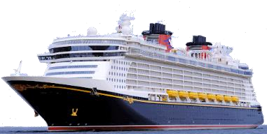
1 | 7 | 15 | 57
A | E | I | O
2 | 4 | 6 | 8
31 | U | 10

Activity Sheet #2

Observe each set carefully and answer the questions that follow.

Set A | Set B
  Fingers on one hand |   Grains of sand on the sea shore

- How many items are in each set?
- Do you observe any difference between the sets you were given? Write a sentence to explain your answer.
- Give one word that would describe the number of elements in Set A and also one word for Set B.

Observe each set carefully and answer the questions that follow.

Set A | Set B
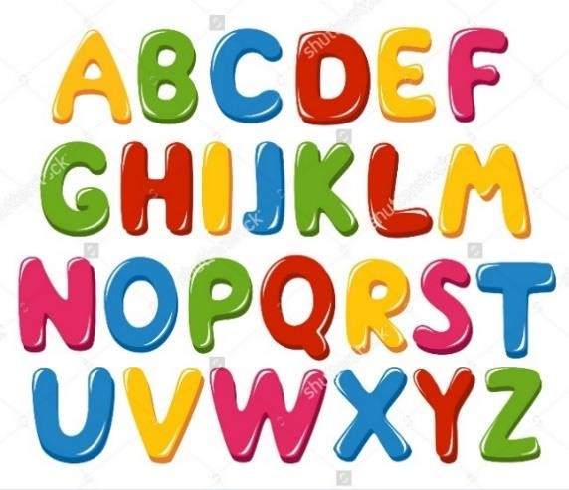  Letters in the English alphabet |   Fishes in the sea

- How many items are in each set?
- Do you observe any difference between the sets you were given? Write a sentence to explain your answer.
Observe each set carefully and answer the questions that follow.

Set A | Set B
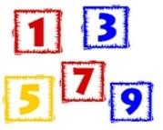 | 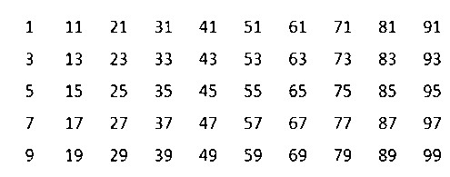…
Odd numbers less than 10 | All odd numbers

- How many items are in each set?
- Do you observe any difference between the sets you were given? Write a sentence to explain your answer.
- Give one word that would describe the number of elements in Set A and also one word for Set B.

Observe each set carefully and answer the questions that follow.

Set A | Set B
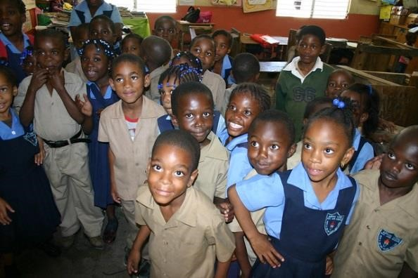 | …
Students in your Grade 6 class | Stars in the sky

- How many items are in each set?
- Do you observe any difference between the sets you were given? Write a sentence to explain your answer.
- Give one word that would describe the number of elements in Set A and also one word for Set B.

Activity Sheet #3
Exit Cards

Make sufficient copies for students in the class. Cut the exit cards and give one to each student.

{whole numbers}

{leaves on a tree}

{number of people in Jamaica}

{multiples of 5}

{children in all the schools in the world}

{trees in the world}

{fractions between 1 and 2}

{seven counting numbers}

{prime numbers}

